11/30/2022
CON 548: Sustainable Construction - P3 Final Report

Concrete 3D printing for Sustainable Construction
Group:
- Dwarak Challa
- Amruth Varagani
- Mohan Kundrapu
- Lakshmi Kanth Reddy Kunchala
- Naga Venkata Krishna Anjani Kumar Majety

Background and Motivation
The construction industry is one of the primary contributors to the world's economy. It is predicted that between 2020 and 2030, the worldwide construction sector, which was $10.71 trillion in 2020, will rise by 42%, or US $4.5 trillion (Future of Construction,2022 n.d.). There have been numerous advancements in construction technology and methodologies used. Yet there are many concerns that need to be addressed. The industry is responsible for many environmental concerns like the usage of fossil fuels, pollution, emission of greenhouse gasses, and construction waste management. Buildings and construction accounted for approximately 34% of worldwide energy demand, 11% of water eutrophication, and around 37% of energy-and process-related CO2 emissions in 2021 which affects the climate. The usage of fossil fuel gasses in buildings has also grown in many emerging economies. The sector accounts for 40% of Europe's energy demand, with fossil fuels contributing 80% of that need. Around 100 billion tons of waste is produced by the construction sector (including renovation and demolition waste) globally. The rising economic, energy, security, and climate challenges both test and emphasize the advancements required to decarbonize, recycle, reuse, and strengthen the global building sector's resilience (Tracking Progress, 2022 n.d.). It is critical that we think about how to meet the current demand and issues with land and resource management without compromising future needs. 3D printing, also known as additive manufacturing, is one such promising method for reducing energy use, water waste, and carbon emissions.
3D printing is an ever-evolving technology used for the creation of an object in three dimensions with the help of the technology-aided additive manufacturing method. It utilizes a series of continuous and repetitive steps to form the object layer by layer. The concept of 3D printing was first proposed in 1983 by Charles W. Hull. This straightforward idea propelled him to develop stereolithography, the foundational technology for 3D printing. Rapid prototyping, which refers to the manufacture of elements quickly, precisely, and repeatedly, usually with computer support, was initially applied to stereolithography. (Izabela HagerAnna GolonkaRoman Putanowicz, 2022 n.d.) This technology has a great impact on the manufacturing, design, biomedical, and AEC (Architectural, Engineering, and Construction) sectors. 3D printing in construction is still in its nascent stages but has a lot of potential in the near future.
3D printing technology has gained a lot of popularity recently with its innovative design, environmentally friendly methodology, faster construction, and great quality and precision. The implementation of 3D printing in construction has numerous advantages. Unlike the conventional process, 3D printing technology has the ability to execute complex designs with ease, reduce overall project budget, mitigate schedule losses, minimize raw material usage, and simplify the work process. In addition to these, the important factors that drive the industry towards this technology are reduction in waste production, energy savings and CO2 emissions, usage of cement substitutes and recycled materials, and sustainable construction. It also addresses the labor shortage and safety of labor in some places as only a small percentage of labor is required to complete the work. 3D printing has recently gained popularity mainly in the residential and commercial sectors. These sectors account for over 29% percent of the industry’s CO2 emissions (Tracking Progress, 2022 n.d.). With the use of this technology in these sectors, these emissions can be reduced.
Relation to topic to the CON 548 class
This project's topic is related to the course's second module, which covers a variety of environmental issues around the world and the impact of buildings on energy, electricity, and water consumption as well as raw material use and water. The construction sector creates a huge impact on Sustainability since this industry utilizes a wide range of materials, resources, and higher levels of energy usage and emits higher amounts of carbon dioxide emission into the atmosphere. Conventional construction techniques limit the level of difficulty in geometry and generate a lot of waste. They are also not environmentally friendly. More than eight percent of carbon dioxide emissions in the entire world are by the production of cement in industries. It can be quite challenging to guarantee that a sustainable strategy is implemented through the entire supply chain for infrastructure projects because they can incorporate several additional companies.
By using 3D printing technology in the industry, we can reduce material consumption and also help in saving time, money, and energy. In comparison to conventional building construction methods, 3D printing technology could be seen as an environmentally beneficent alternative that offers virtually endless options for the fulfillment of features and designs. The contour Crafting (CC) technique is the most effective 3D printing method utilized in the construction sector. This approach involves layer-by-layer laying of the material, but still, the entire process happens on-site. By using a 3D printer that can build an entire house on-site, this technology provides an important chance for computerizing the construction workflow. There are many benefits to using this technology, which include decreased costs and time, less environmental degradation, and fewer complications and homicides on building sites. Additionally, 3D printing will make it possible to construct massive elements with the highest level of efficiency and aesthetic freedom.
Impact on customer segments:
Customer segments like residential sectors, owners, and general contractors are benefited.

Problem: There is a need for 4 million houses across the US (Fields, S. (2022)).
- To meet this demand in a sustainable, efficient, and faster way, 3D printing can be a great option.
- As the construction phase of the project can be completed faster than the conventional, 3D printing can save a lot of time in meeting the demand.
- It can also answer the labor shortage problem.

Problem: A lot of money, time, and materials are lost due to schedule changes, labor shortages, mistakes in implementing design
- 3D printing can help save these as it requires minimal labor, schedule changes, and budget.
- The application of formwork (arranging and removal) in the field takes significant percentage of the total project duration. This can be reduced by using 3D printing.

Methodology
A primary objective of this project is to compare 3D printed houses with conventional R.C.C. structures, based on Indian codes of provisions and costs. This analysis is mainly concerned with the materials that influence the sustainability of the environment, such as sand, cement, aggregate, and steel as well as missionaries and heavy equipment involved during construction. This project involves the case study of a 3D printed house in Tempe, A.Z by Habitat company. A few modifications are made to the R.C.C model for practical challenges in design without affecting the construction area for comparative analysis. By designing a prototype with reinforced concrete cement, we can examine how cost and materials will change with the process and how they will contribute to sustainability for both conventional R.C.C. building with the 3D printed house.

Analysis for Convectional R.C.C house:
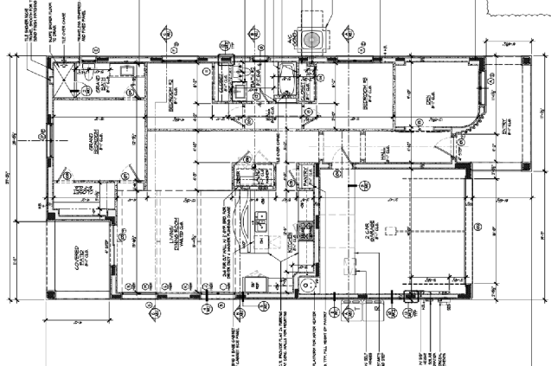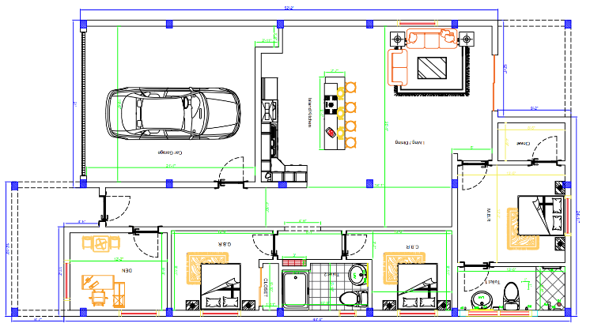
Fig-1: Actual 3D printed house in Tempe Fig -2: Modified plan for R.C.C. structure
Preliminary design for R.C.C structure:
In order to determine the properties of the structural members like beams, columns, and slab, a preliminary design is performed to obtain the sizes of those structural members to perform further design analysis in Staad pro to check whether to check the structure will stand for the given design parameters.
Preliminary design of slab:
d =$\frac{ length of shoter span of largest slab panel}{35 to 42}$ [d is effective depth of slab]
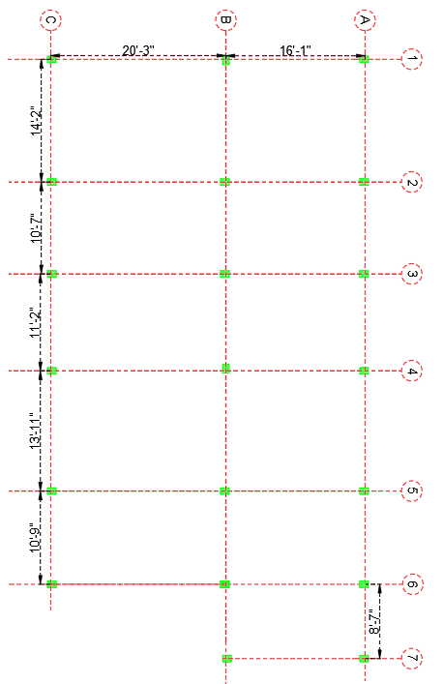
Fig -3: Column layout plan
Largest slab panel is B₁B₂C₁C₂
Length of shorter span of largest slab panel is 14’2’’ = 4.31m --- d = $\frac{4.31}{42}$ = 0.102m = 102mm = 150mm approx.

- Preliminary design of beam:
d = $\frac{span of beam}{12 to 15}$ = 6.17/15 = 411 mm, largest span of beam = 20’3’’ = 6.17m
D = d+$\frac{1}{2}$ (bar dia) + C.C [ C.C = Clear cover, D = overall depth]
D = 411+8+25
D = 450mm and B = 2/3 (450) = 300 mm =12’’ [where D = depth of beam, B =breadth]
- Preliminary design of column:
P_{u} = 0.4 F_{ck} (A_{g}-A_{sc}) + 0.67 x f_{y} x A_{sc} [P_{u} = ultimate load, F_{ck} = characteristic strength]
The ultimate load is the summation of loads exserting on column those are floor finish, self-weight of the slab, beam and column, earth quack load are as follows as per the calculations done by IS standards give Pu as 279000 N/m2 approx. 300000 N/mm2
A_{sc} should be in ranges 0.8% to 6% of the A_{g} where A_{g} is gross c/s of column and A_{sc} is gross c/s of steel in column so by considering 4% gives A_{sc} = 0.4 A_{g}
300000 = 0.4 (20) (Ag – 0.04Ag) + 0.67 x 500 x 0.04 Ag
Ag = 13611.6 mm2
As per IS:456 minimum size of column should be 225mm x 225mm which is 9”.
Design of structure in Staad:
With the results obtained from the preliminary design calculations, a Staad model is developed to check the structural stability of the structure and to obtain concrete and steel take-offs from the Staad output file.
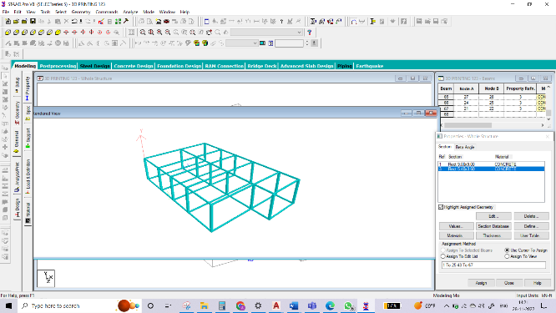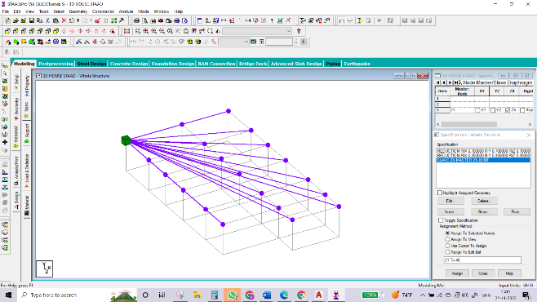
Fig-4: Rendered view of structure Fig-5: Assigning the master slave for floors

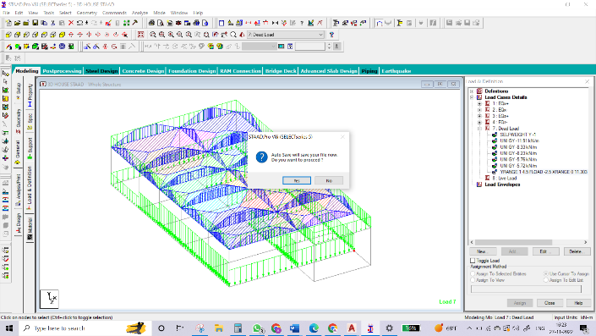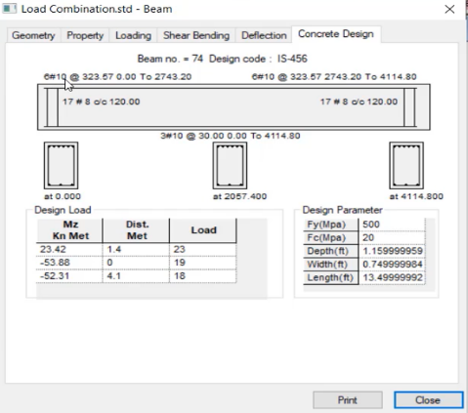
Fig-6: Application of loads and design parameters Fig-7: Beam design results
The total concrete take-off with M20 grade obtained for columns, beams, and slab through Staad output is = 87.11 m³
Total cement required = 35105.33 kgs
The total steel required Is = 5723.4 Kg
The cost of construction per SQFT is 1800/- so the total cost is = Rs 42,30,000/-

Analysis for 3D house
The construction of 3D printed houses can be done in two methods with Gantry systems and robotic arm systems, the present 3D printed house in Tempe is constructed using the gantry system, as gantry printers are more advantageous in terms of cost and stability and also gives the great scope to make large prints, whereas the robotic arm printers are quite quick and movable it requires a high expert to operate because of the complexity and detail.
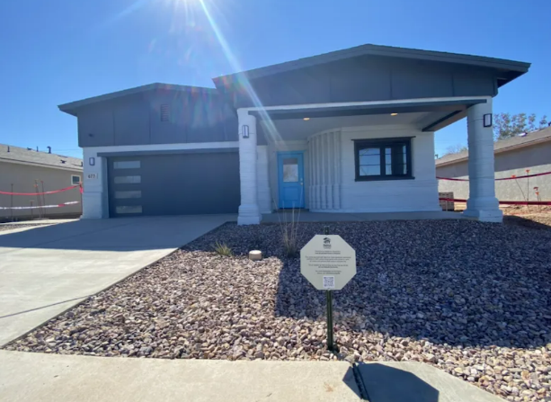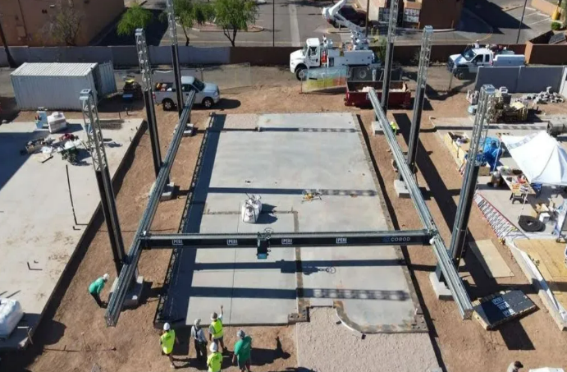
Fig-8: 3D printed house at Tempe used in this study Fig-10: Concrete printing using Gantry system
As the major concern involved in this current comparative analysis is to find the raw materials affecting sustainable aspects like cement and steel, obtaining these quantities from the constructed house is quite difficult, so the approach to calculating the quantity of concrete Is different, which is done based on the speed of the 3D printer, discharge volume of concrete per sec, and total path length of the house as well as the mix proportions of concrete. With these known parameters we can determine the quantity of concrete used for this construction excluding the wastage.
In order to calculate the quantity of cement required for this construction it is very important to find the mix ratios and raw materials, superplasticizers, retarders, etc. used in the mix design during the construction, the concrete mix design for the 3D printed construction is not as same as the conventional R.C.C house, the major goals for mix design is to maximize workability, compressive strength, flowability in the system, buildability on poring, speed of concrete setting time, and to properly maintain the setting rate with different retarders and plasticizers to ensure the accurate setting between two subsequent layering’s.
Common Mix proportions used are as follows:
Sand: Binder = 3:2, where Binder contains 70% of cement, 20% of fly ash and about 10% of silica fumes add on to these super plasticizers and retarder are also used to control the setting time, workability of concrete which are in the ratio of 1% and 0.5% respectively.
The machine speed is determined with the help of the rate of extrusion of the mix, these following results are obtained from the Tvasta group based on the analysis performed in IIT Chennai, India.
Discharge of concrete from nozzle is = 0.09 lit / sec
Velocity of the concrete printer = 18.74 cm/sec
Thickness of each extrusion layer = 15mm
Width of the layer used = 25mm

In many cases the speed of the machine will be approximately equal so assuming that the same speed is used for the concrete 3D printer used for the construction of a current 3D printed house in Tempe.
From the floor plan in Fig 1 we can see the external walls are of 4 layered extrusions with 2 layers side by side on both interior and exterior side with a hollow gap of 6’’ provided for the insulation and placement of rebars to withstand the tension forces.
Height of the building = 11’ = 3352.8mm
No of layers required to attain the height of the structure is done using the interpolation as the layer’s subjects to compression due to the self-weight of the concrete so at each layer 15mm thickness of extrusion cannot be obtained
Total number of layers required to attain the height of 11’ = 223.52 layers of extrusions
From the interpolate values total number of extrusions required for a 11’ heigh house is = 241
(Note: The interpolate values are calculated from the graph obtained from the experimental results done by Tvasta group)
So total length of external wall is = 232’ 9’’ = 7185.66 cm
Total time required to extrude first layer = $\frac{7185.66}{18.74}$ = 383.4 sec
Total time required to lay 241 layers = 241 x 383.4 = 92399.4 sec
Total number of side-by-side layers present in exterior wall are = 4 so 4 x 92399.4 = 369597.6 sec
Number of side-by-side layers in interior walls = 2
Total length of the interior walls as per the plan mentioned in Fig 1 = 126.35’ = 3851.1mm
Total time required to cover the length of 126.35’ = $\frac{3851.1}{18.74}$ = 205.50sec
Total time required to lay 241 layers one on another = 205.50 x 241 = 49525.8 sec
Total number of side-by-side layers in interior walls are 2 = 2 x 49525.8 = 99051.77 sec
The total time required to construct all walls = 99051.77+ 369597.6 = 4,68,649.37 sec
As we have the discharge volume = 0.09 lit/sec we can find total volume for 4,68,649.37sec
Total volume of concrete required = 4,68,649.37 x 0.09 = 42178.4 lit
Binder is 2 parts of the total volume and cement is 70% of that 2 parts weight of cement = 17714.85kgs
Weight of 8mm steel bars = 0.395Kg/m
Total number of reinforcement points in the plan with 6 rebars of 8mm are 30, so the total number of rebars up to height of 3.3m are 6 x 30 = 180 rebars, where each rebar length is 3.3 meters = 180 x 3.3 which is = 594 meters weight of steel = 594 x 0.39 = 231kgs

Total approximate weight of steel used = 231kgs.
Cost of construction of this 3D printed house in India will costs according to Tvasta = Rs. 24,14,666/-

Results

Fig-11: Bar chart for consumption of cement.
Above bar chart we can see that the usage of cement is reduced to almost 50% of that of the usage in conventional R.C.C buildings which is used almost in all countries, as the quantity of cement decreases the cost of the raw materials is also decreasing, production of cement involves a lot of pollution because of excessive production of carbon dioxide (CO2), for every 1 kg production of cement produces 2.06 kgs of carbon dioxide, concrete in foundation affects the fertility of the topsoil whereas in the 3D printing it can be avoided.

Fig-12: Bar chart for consumption of Steel.
Even though steel is a sustainable material the manufacturing of steel will greatly affect environmental sustainability where production of 1 ton of steel produces approximately around 1.9 tons of carbon dioxide which causes global warming, and more production of steel also contaminates water, and produce harmful solid waste. The usage of steel in 3D construction is very minimal compared to conventional buildings, especially for single-storied constructions.

Fig-13: Bar chart for cost analysis
3D printed buildings cost comparatively less than conventional buildings which are approximately fifty percent of the cost, the 3D printing also enables the fast delivery of the project which minimizes manpower, transportation cost, fuel, electricity, wastage of raw materials, noise pollution, etc. which is beneficial in both customer and environmental sustainability perspective, more over the complex shapes can also be achieved on site which improves the aesthetics of architecture.
Conclusion
As per the data obtained from the design calculations and analysis performed by both conventional houses and 3D printed houses, 3D constructions are way better than that of the conventional method of construction, 3D construction is environmentally friendly as well as sustainable, as it uses industrial waste like fly ash, GGBS, silica fume, etc. which reduces the cost as well as the manpower, currently the trend of 3D constructions is rapidly increasing in many countries, replacing of the single storied residential building sector in the world with 3D printing construction can show a greater effect on sustainability, by minimizing the production of cement, steel, and cost at a larger scale.
If fully implemented, 3D printing can help in faster completion of projects, reduce the overall waste production by the industry, usage of recycled materials (as they can be used as the printer ink), reduction in project costs and raw materials, reduce CO2 emissions, and energy demand. Leading countries like the USA, the UK, and Germany, to list a few have shown substantial interest in this technology and approved the design. It still needs a lot of support to implement in a larger scale. Currently, the construction in 3d printing is limited to 3 storied buildings and is confined to residential and commercial sectors, to implement in major structures, advancements are essential. With the help of technological innovations and support from industry, 3D printing has remarkable potential in the construction space for generations to come.
References:
- Hager, I., Golonka, A., & Putanowicz, R. (2016). 3D printing of buildings and building components as the future of sustainable construction? Procedia Engineering, 151, 292–299. https://doi.org/10.1016/j.proeng.2016.07.357
- Future of Construction. (n.d.). Oxford Economics. Retrieved November 29, 2022, from https://resources.oxfordeconomics.com/hubfs/Future%20of%20Construction_Full%20Report_FINAL.pdf
- Sustainable construction: How 3D printing can help. Emerald Publishing. (n.d.). Retrieved November 29, 2022, from https://www.emeraldgrouppublishing.com/archived/realworldresearch/innovation/how-3D-printing-can-make-construction-better.htm
- Tracking progress. Globalabc. (n.d.). Retrieved November 29, 2022, from https://globalabc.org/our-work/tracking-progress-global-status-report
- Effectiveness of 3D printing in construction industry over the ... - IJISRT. (n.d.). Retrieved November 29, 2022, from https://ijisrt.com/assets/upload/files/IJISRT21JUN1029.pdf

